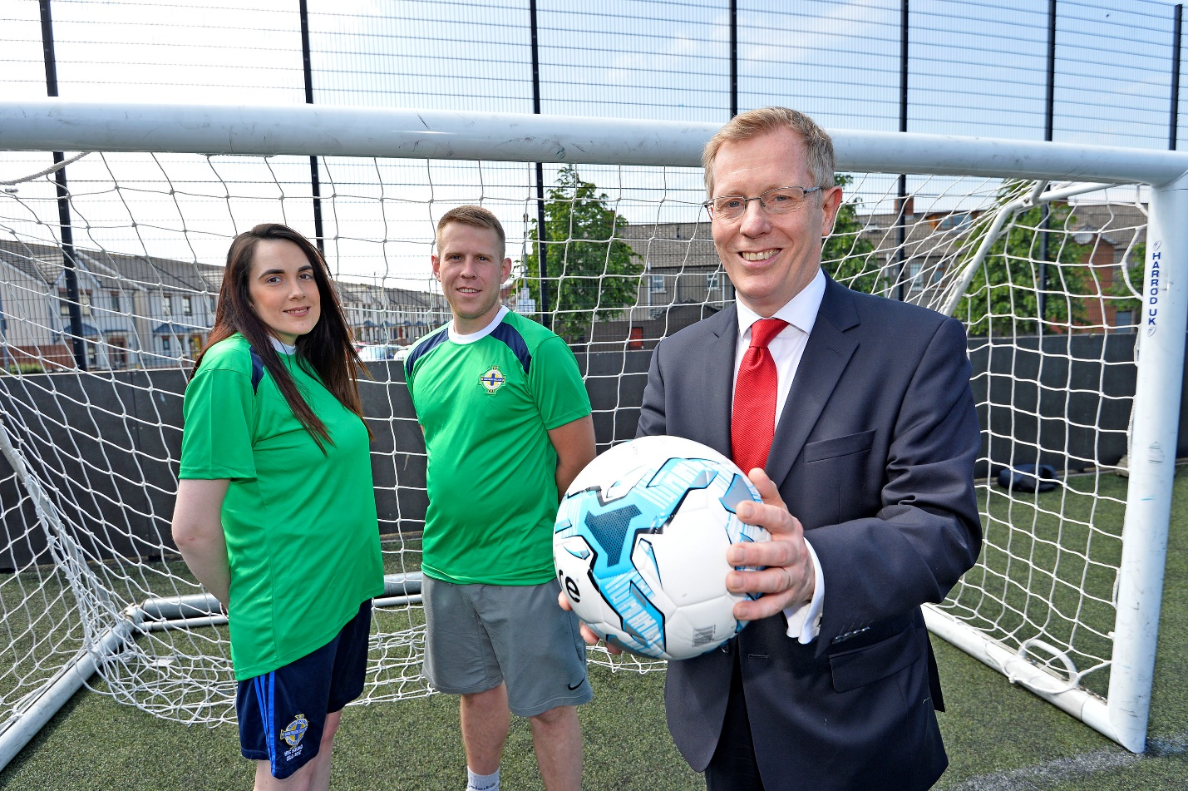


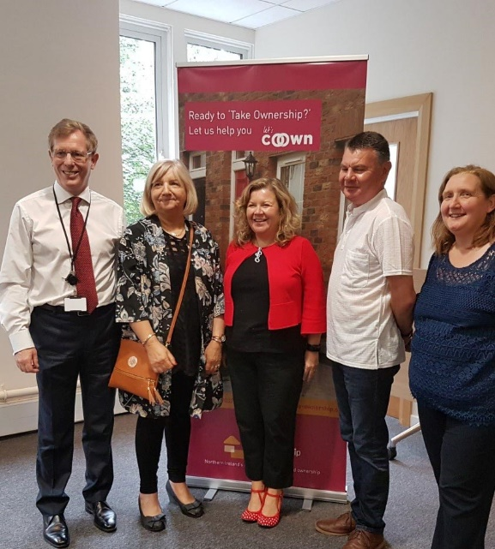

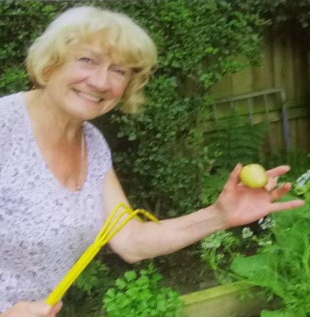
Community Fund
2026/27
co-
owner
ship.
org

Application

Co-Ownership Community Fund 2026/27

Co-Ownership is a values led organisation and has a strong sense of its social purpose. Besides getting people into homes, we strive to make a positive impact on wider society. One of the ways in which we do this is through the community fund. Since its launch in 2017, the community fund has paid over £135,000 to a variety of community projects across Northern Ireland.

The Community Fund has an overall budget of £20,000 in the 2026/27 financial year which will be allocated at our discretion.

This year we want to support a project or projects which will:

- Regenerate, rebuild, and revitalise neighbourhoods and communities;

- Support disabled people;

- Encourage:
- Energy efficiency,
- Biodiversity,
- Sustainability,
- The circular economy.

We’d particularly welcome applications from small community based and/or volunteer led organisations.

Previous recipients should not reapply within 24 months.

Please complete this application form and return by: Friday 29 May 2026 at 5.00pm

Please refer to the supplementary guidance document to help you complete the application but if you have any additional questions, email: ghughes@co-ownership.org or glavery@co-ownership.org or telephone 02890 327276.

Contact details

Name of lead organisation: Click here to enter text.

Names of any partner organisations: _{Click here to enter text.}

Name of contact person: Click here to enter text.

Address: Click here to enter text.

Post code: Click here to enter text.

Telephone no: Click here to enter text. Mobile no: Click here to enter text.

Email address: Click here to enter text.

Tell us about your organisation(s) e.g. what do you do? What areas do you cover? (word limit of 200 words)

Click here to enter text.

Your Project Idea:

Is there a name for your project?

Click here to enter text.

Please tell us what you plan to do and why there is a need for such a project; (word limit of 200 words)

Click here to enter text.

Approximately how many people will benefit from your project? What age groups or backgrounds?

Click here to enter text.

What preparation work has been done / will be done for your project e.g. how will you recruit participants, volunteers etc? (word limit of 150 words)

Click here to enter text.

Project Costs

The £20,000 budget will be allocated at our discretion across a single or multiple projects.

How much will the project cost and what will you spend the money on? (Please note we would urge you to use existing resources where available and encourage clear value for money. Funding will not be allocated to cover ongoing staff or premises costs)

Item / Activity / Cost | Amount needed
For example;  Materials  Equipment costs  Venue Hire  Transport costs | Click here to enter text.
Total | £ Click here to enter text.

Bank Details

Please give full bank account details of your organisation (please ensure these are accurate as, if you are successful, we will pay the grant directly into this account)

Bank Name: Click here to enter text.

Branch Address: Click here to enter text.

Bank Account Name: Click here to enter text.

Sort Code: Click here to enter text. Account Number: Click here to enter text.

Organisation Governance Checklist

Please tick to confirm your organisation:

Is based in N. Ireland and has a signed and dated governing document;
e.g. constitution, company articles ☐

Has a bank account in the name of the organisation ☐

Has annually audited accounts ☐

Has a child protection policy (where appropriate) ☐

Has a vulnerable adults policy (where appropriate) ☐

Who will be responsible for the financial claims for this project?

Please sign your name below to confirm that the information provided in this form is correct and that you will be the person responsible for the grant funds. We will accept electronic / typed signatures;

Name: Click here to enter text.

Position: Click here to enter text.

Signature: Click here to enter text.

Completed applications should be returned by 5pm on 29 May 2026 either by

email to:glavery@co-ownership.org

or by post to:
Gillian Lavery
Community Fund
Co-Ownership
Moneda House
25-27 Wellington Place
Belfast
BT1 6GD

What happens then?

After the closing date for applications, a panel will be convened by Co-Ownership to choose the successful projects. Discretion rests with the panel, which may be pragmatic in varying any of the terms of this application process, and its decision is final. Award of grants will be made through a letter of grant offer and will be conditional on applicants signing a contract.

IMPORTANT: If you have sent us an application and have not received an acknowledgement of receipt within 7 days, please contact us to ensure that we have received your application successfully.

co-
owner
ship.

org
Moneda House, 25-27 Wellington Place, Belfast, Belfast BT1 6DN

Call 028 9032 7276
hello@co-ownership.org

